# XBCAD Final Deliverable – ppe pro track.

Members

1. Halalisani
2. Ndumiso
3. Uzair
4. Blessed

Good day Gentlemen.

I have not gone into details of what each person should do but each member has been allocated a section. We can refer to the screenshot on the group for guidance and the recording found here : <https://advtechonline-my.sharepoint.com/:v:/g/personal/st10092443_vcconnect_edu_za/ES5p-L0w3gdOmkioBMuJo3gBu8-AOCYUJZmlaV9wQk5sNw>

# Delegations

* **All delegations from Deliverable 3** 
  + Note that some may be already started as seen below.

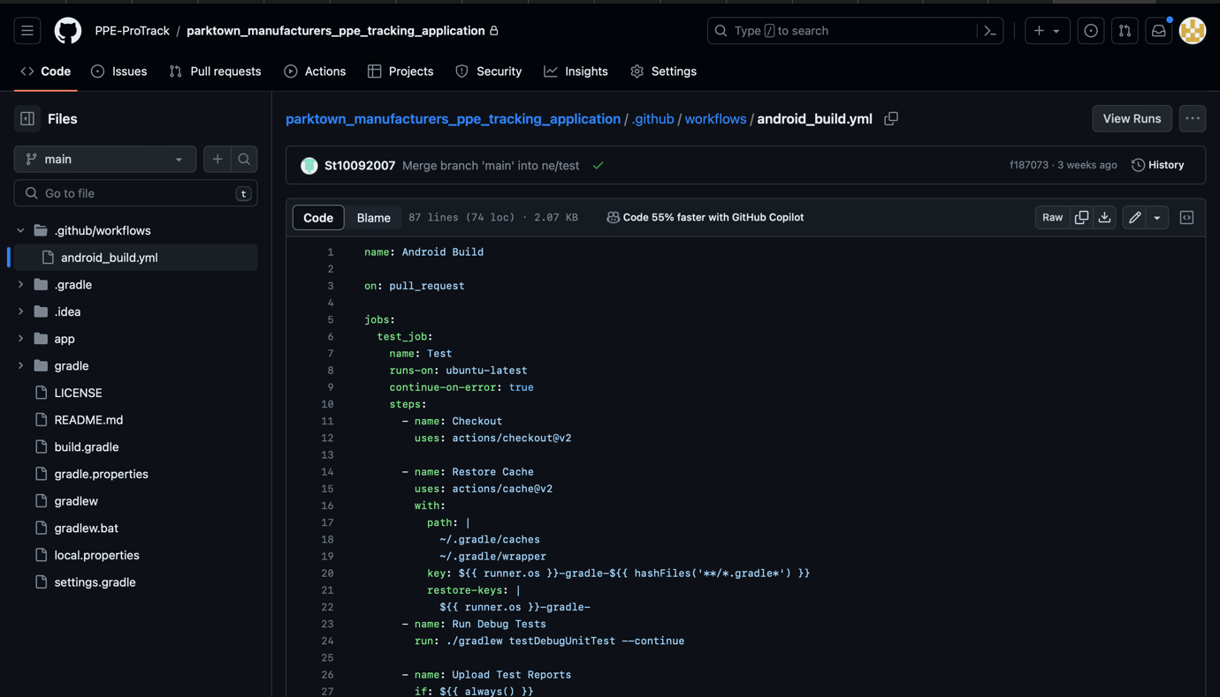

Sections

* Employees – Ndumiso
* PPE items - Uzair
* Departments – Blessed
* Issuance – Hala

# Note

* The deadline **Sunday @ 21:00.**
* We will have a meeting on **Sunday @ 21:00** To smooth over any issues that are remaining.
* The presentation planning be done then.
* If you need assistance feel free Please don’t hesitate to reach out on the group.

# GitHub

* I have invited all of you as collaborators as seen in the figure below :

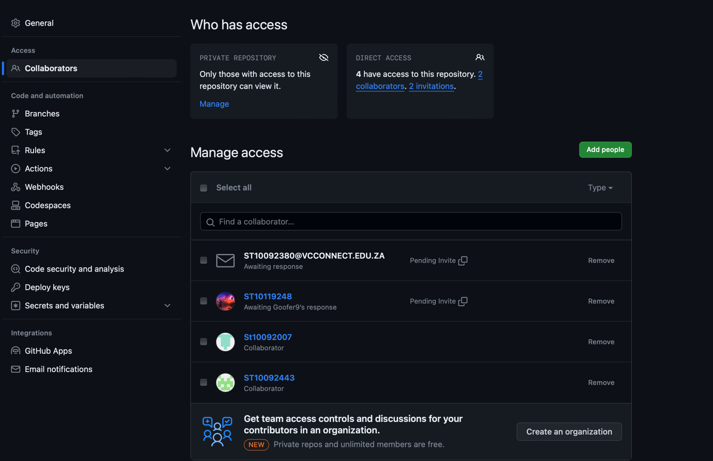

Figure 1 Invitations

* GitHub link : <https://github.com/PPE-ProTrack/parktown_manufacturers_ppe_tracking_application.git>